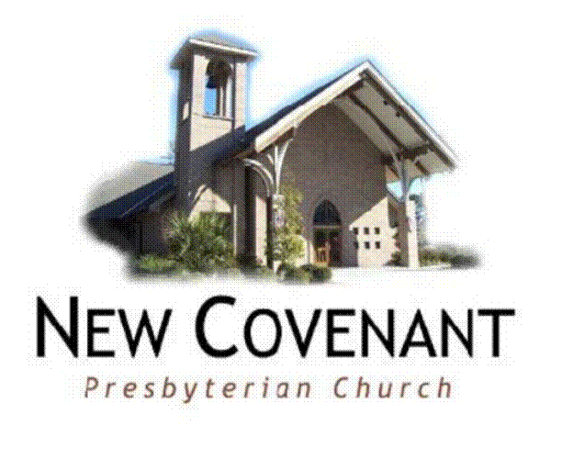
New Covenant Presbyterian Weekday School
A ministry of New Covenant Presbyterian Church (EPC)
4375 Hwy 22
Mandeville, LA 70471
(985) 626-1627
www.newcovenantpc.org
wkds@newcovenantpc.org

Welcome to New Covenant. We’re excited that you’re considering New Covenant Weekday School for your child. The New Covenant Weekday School is sponsored and operated directly under the supervision of the Session of New Covenant Presbyterian Church and its Children’s Ministry Team. The Session having sensed the need for strong Christian influences in our community, endorsed the organization of this school as an evangelistic arm of New Covenant. It is our prayer that its use and influence will be felt widely throughout this community to the glory and praise of God Almighty.

New Covenant Weekday School is a Christian Montessori school. Our classrooms have eight distinct areas that define the curriculum of the school. Our teachers direct the children in the use of the materials and encourage them to interact with the materials independently. This environment establishes the educational direction of the school. The areas include Sensorial, Practical Life, Math, Language, Bible study and Chapel, Science, Geography, Music, Art, and Outdoor Play.

The Weekday School offers two, three and five day programs. Children must have their 2nd birthday prior to October 1st for admission. Children entering the five day must be potty-trained. If you would like more information about the school or would like a tour for potential admission, please contact the Weekday School at (985) 626-1627.

We also pray that you’ll consider New Covenant Church as a home for you and your family as well. New Covenant, the church, is a covenanted body of people who profess and give evidence that they have been saved by God’s grace alone, for His glory alone, through faith alone, in Christ alone under the authority of Scripture alone. We are a local, living, and loving collection of people who are committed to Christ and committed to each other.

We worship our Lord Jesus Christ together on Sunday mornings. Our traditional service is at 9am, and our contemporary service is at 11am. All children are welcomed in worship. We have nursery for children birth - 3 years located in the school building. We also offer Children’s Church currently during both our 9am and 11am service.

If there is anything we can do to serve you please let us know.

In Christ,

Katy Cook Chris Eberdt
Director of the Weekday School Director of Operations

New Covenant Presbyterian Weekday School
4375 Highway 22
Mandeville, LA 70471
(985) 626-1627

DATE:___________________________________

Please register_____________________________________________________________
For the New Covenant Presbyterian Weekday School 2024 - 2025 school year. I have indicated a first and second choice for the programs in which I am interested:

An application does not guarantee a place in the school. Priority will be given to members of New Covenant Presbyterian Church. The Children’s Ministry Team will review the applications annually and will be responsible for the class rosters.

5 DAY PROGRAMS (For children 3 & 4 years old)
___________ 9:00 – 1:00 ½ Day Program
___________ 9:00 – 3:00 Full Day Program
___________ 7:30 – 9:00 A.M. Care
___________ 3:00 – 5:00 P.M. Care

3 DAY PROGRAM (Monday, Wednesday, Friday) for children 2 – young 3 year olds
___________ 9:00 – 1:00 __________A.M. Care
___________ 9:00 – 3:00 __________P.M. Care

2 DAY PROGRAM (Tuesday, Thursday) for children 2 – young 3 year olds

___________ 9:00 – 1:00 __________A.M. Care
___________ 9:00 – 3:00 __________P.M. Care
New Covenant Presbyterian Weekday School
4375 Highway 22
Mandeville, LA 70471
(985) 626-1627 fax (985)-626-4391
E-mail: wkds@newcovenantpc.org
katy@newcovenantpc.org

Name of Child_______________________Nickname______________________Child’s Sex: _____

Address ___________________________________________________________________________
City _________________________State ______ Zip Code ____________ Phone_________________
Date of Birth ______________________ Parent’s Names:____________________________________
Father’s Place of Employment: _________________________________________________________
Mother’s Place of Employment: ________________________________________________________
Work Phone: Father’s_________________________________ Mother’s________________________
Cell Phone: Father’s ________________________________ Mother’s _______________________
Does child live with
Both parents?

E-Mail Address: ____________________________________
Please print clearly. Please notify us by e-mail if it changes during the year.

Child’s Doctor and Phone Number: ______________________________________________________
Siblings Names and Dates of Birth: ______________________________________________________
__________________________________________________________________________________
How long have you lived in this area? _________________ Are you active in a local church?________
May we ask which one? _______________________________________________________________
How did you hear about the preschool? __________________________________________________
__________________________________________________________________________________
Would you like more information about New Covenant church programs?______________________
Previous schools your child has attended: _______________________________________________
Have any of your children ever attended our Weekday School or? _______________________

HEALTH CONSIDERATIONS:
Contagious Diseases / Illnesses_________________________________________________________
Serious Accidents/ Injuries ____________________________________________________________
Allergies___________________________________________________________________________
Other medical information that would assist us in better understanding your child’s needs:
__________________________________________________________________________________

______________________________________________ ________________________
Signature of Parent or Guardian Date

New Covenant Presbyterian Weekday School
4375 Highway 22
Mandeville, LA 70471
(985) 626-1627
E-mail: wkds@newcovenantpc.org
katy@newcovenantpc.org

TUITION SCHEDULE 2024-2025

MONTHLY ANNUAL
PROGRAMS TUITION TUITION (10 months)
Monday – Friday

9 – 1 ½ Day $ 575.00 $ 5,750.00
9 – 3 Full Day $ 670.00 $ 6,700.00
A.M. Care $ 160.00 $ 1,600.00
P.M. Care $ 200.00 $ 2,000.00

Monday, Wednesday, Friday
9 – 1 $ 425.00 $ 4,250.00
9 – 3 $ 485.00 $ 4,850.00
A.M. Care $ 95.00 $ 950.00
P.M. Care $ 120.00 $1,200.00

Tuesday, Thursday
9 – 1 $ 295.00 $ 2,950.00
9 – 3 $ 325.00 $ 3,250.00
A.M. Care $ 65.00 $ 650.00
P.M. Care $ 80.00 $ 800.00

There is a non-refundable registration fee of $250.00, which is due with the application form. The first month’s tuition is due May 1st or with the registration fee per late applicants registering.

Your tuition includes a school provided snack.

